H.T No
Regulations:
A17

Sreenidhi Institute of Science and Technology
(An Autonomous Institution)
Code No: 6W104 Date: 24-Jan-2019 (FN)

M.Tech I-Year I-Semester End External Examination, Jan/Feb-2019 (Regular/Supplementary)
ADVANCED MECHANICS OF SOLIDS (CAD/CAM)

Time: 3 Hours Max.Marks:75

Note: a) No additional answer sheets will be provided.
b) All sub-parts of a question must be answered at one place only, otherwise it will not be valued.
c) Missing data can be assumed suitably.

Part - A Max.Marks:25

Answer all QUESTIONS.

1. | State Hooke’s law and the principle of superposition. | [3M]
2. | Define bending axis and state its significance. | [3M]
3. | What are the correction factors associated with curved beams? | [3M]
4. | State Prandtl’s Elastic membrane analogy. | [3M]
5. | Explain Rayleigh’s -Ritz method. | [3M]
6. | State the Principle of Griffith Energy balance. | [2M]
7. | State Castigliano’s First Theorem. | [2M]
8. | What are Winkler Bach correction factors? | [2M]
9. | State Green’s theorem. | [2M]
10. | What is the significance of Euler’s buckling load principle? | [2M]
Part – B Max.Marks:50
ANSWER ANY FIVE QUESTIONS. EACH QUESTION CARRIES 10 MARKS.

11. | a) | State and derive Second Theorem of Castigiiano. | [4M]
 | b) | Determine the support reaction for the beam shown in the figure 1 below.  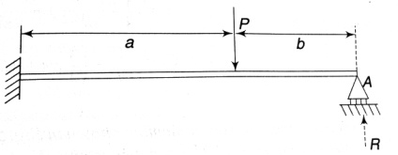  Figure 1 | [6M]
12. | a) | Derive expression for Deflection of straight beams subjected to Unsymmetrical bending. | [5M]
 | b) | Determine the location of the shear center of the section shown in the figure 2 below.  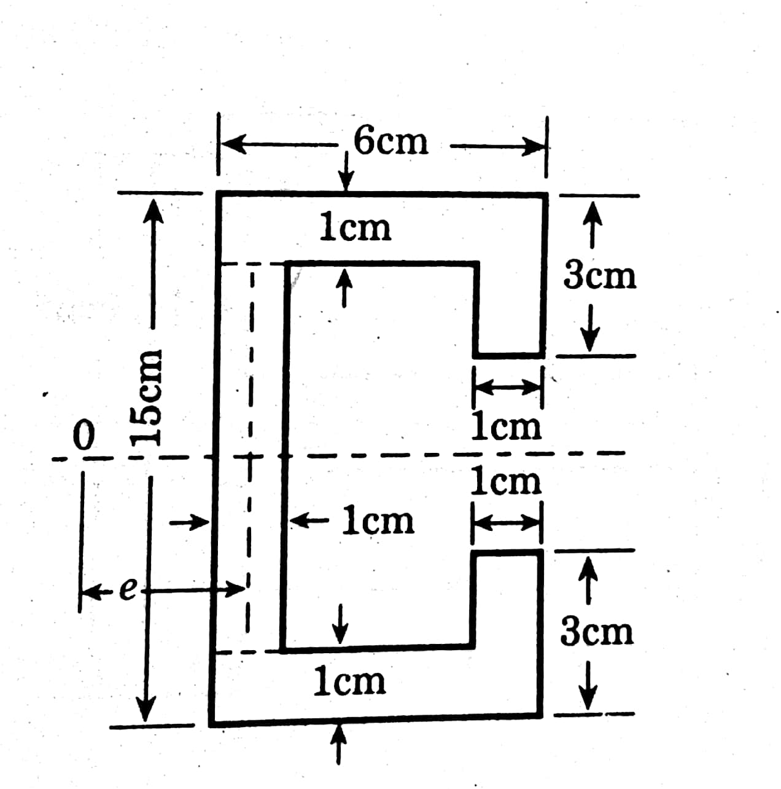  Figure 2 | [5M]
13. | a) | Describe the changes that occur in stresses when a frictional load is considered along with a normal load on the contact area. | [4M]
 | b) | Two carbon steel balls each 25mm diameter are pressed together by a force F=18N.At the centre of the area of contact. Determine the values of the principal stresses the maximum shear stress and the Octahedral Shear stress. | [6M]
14. | a) | Discuss the torsion of thin walled tubes. | [4M]
 | b) | A solid shaft is transmitting 75KW at 200 rpm taking allowable shear stresses of 70 MPa. Find Suitable diameter of the shaft, if the maximum torque transmitted in each revolution exceeds the mean by 30%. Also find the outer diameter of hollow shaft whose inside diameter is 0.7 of the outside which can replace the solid shaft. | [6M]
15. | a) | State and explain the theorem of Stationary potential Energy. | [5M]
 | b) | The deflection curve for a pin-ended column is represented by a polynomial as y=ax⁴ + bx³ + cx² +dx + e  Determine the critical load by energy method. | [5M]
16. | a) | Discuss J -integral as a fracture criterion. | [5M]
 | b) | A 75cm wide steel plate has a central crack of length 2a=10 cm the plate is 5mm thick. The plate is pulled to fracture and fracture load is 800KN. Determine the stress intensity factor assuming a/w as small Also, determine the values of fracture resistance R (take E=207 GPa) | [5M]
17. | a) | Explain the principle of virtual work. | [3M]
 | b) | Determine the general expression for torsion of a cylindrical bar of circular cross section. | [4M]
 | c) | Define crack tip opening displacement (CTOD) and explain its relationship with J-Integral. | [3M]

-- 00 -- 00 –

